CLIMATE ACTION AND
RESILIENCE PLAN Template
March 2023

Acknowledgements

We acknowledge the Traditional Custodians of all the lands on which Jesuit Social Services operates and pay respect to their Elders past and present. We express our gratitude for their love and care of people, community, land and all life.

This framework was co-designed by Jesuit Social Services’ Centre for Just Places and the Darebin Neighbourhood House Network in 2022 with funding support from Melbourne’s Climate Journey. Melbourne’s Climate Journey is a community-led project supporting Greater Melbourne communities to adapt to a changing climate, supported by the Department of Environment, Land, Water and Planning (DELWP) and funded through the Supporting Our Regions to Adapt program.
The Centre for Just Places was established by Jesuit Social Services, with significant seed funding from Gandel Foundation and the Victorian Government, to enable and support place-based approaches nationally through research, collaboration, engagement and knowledge exchange.

Using the Climate Action and Resilience Plan template
This Climate Action and Resilience Plan template accompanies a Climate Action and Resilience Planning for Neighbourhood Houses Guidance Document which guides and supports neighbourhood house networks to come together to address and respond to the impacts of climate change.
This template introduces key climate change concepts, including sustainability and resilience, and explores the important role neighbourhood houses can play in our community.

The template was co-designed by Jesuit Social Services’ Centre for Just Places and the Darebin Neighbourhood House Network in 2022. It includes content from the Darebin network’s Climate Action and Resilience Plan which may not be relevant to your network. The template contains text in red that is intended to be edited by neighbourhood house networks to reflect their context and climate action commitments.
This template is accompanied by:
- Climate Action and Resilience Planning for Neighbourhood Houses Guidance Document; and
- A self-reflection survey to support each house to look at their strengths and opportunities for action.

The Community Adaptation Action Plan template begins on the next page. Neighbourhood house networks may choose to delete some pages including:
- Jesuit Social Services’ Centre for Just Places Climate Action and Resilience Plan Template cover page
- Jesuit Social Services’ Centre for Just Places Acknowledgement of Country
- Using the climate action and resilience plan template instructions (this page)
- The final acknowledgement and contact page

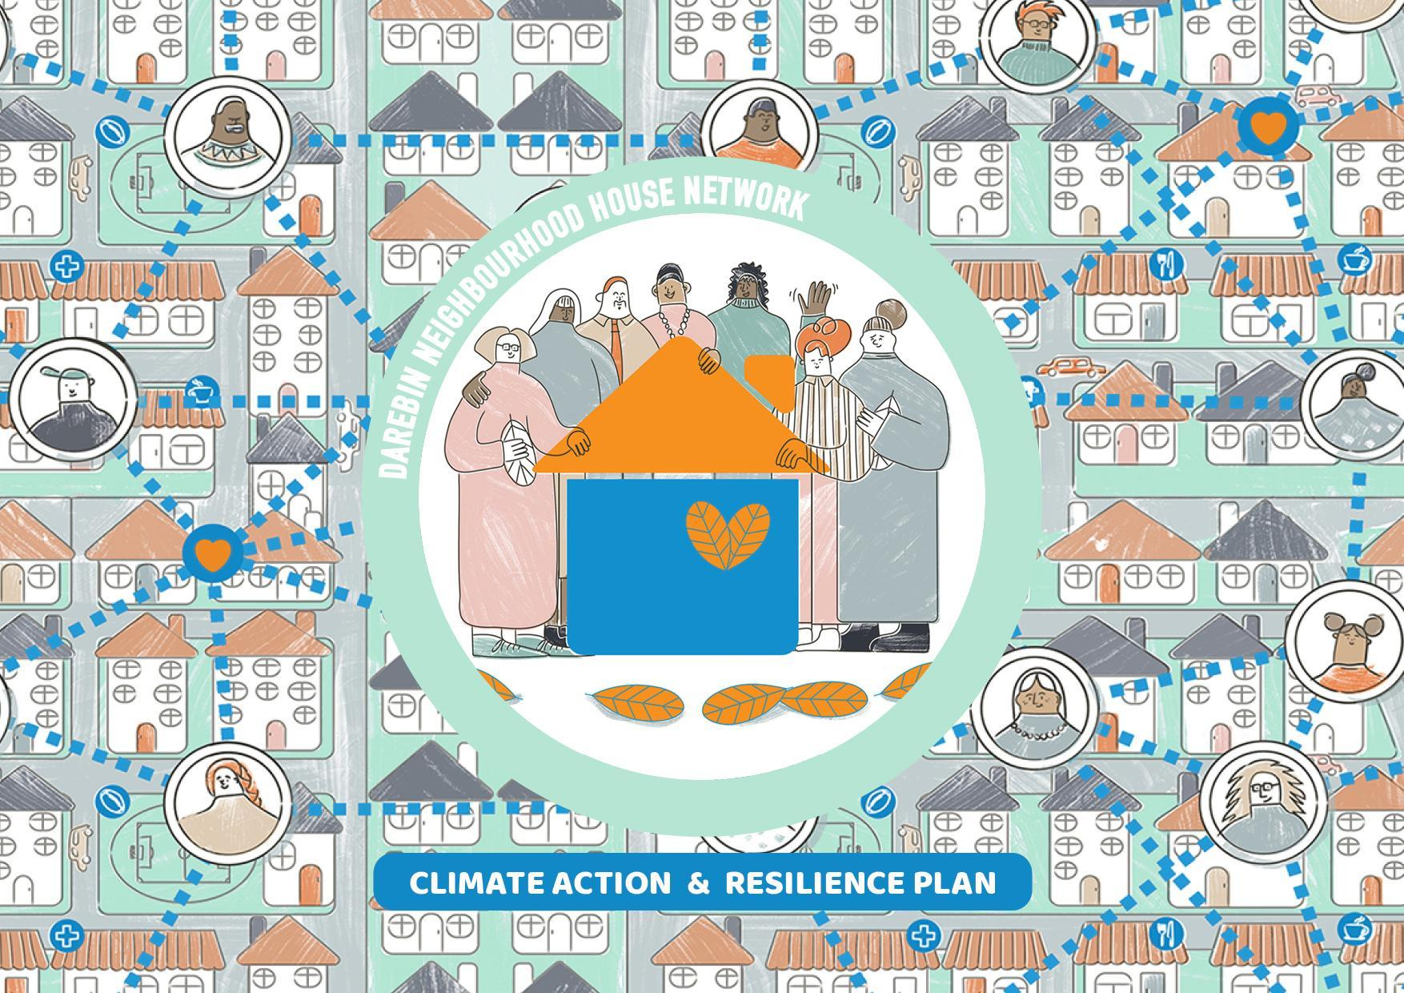

CONTENTS
Acknowledgement of Country…………………………………………………………………………………………………………………………………………5
Executive summary………………………………………………………………………………………………………………………………………………………6
Introduction…………………………………………………………………………………………………………………………………………………………8
Background…………………………………………………………………………………………………………………………………………………………9
Climate justice………………………………………………………………………………………………………………………………………………………10
Mitigation………………………………………………………………………………………………………………………………………………………10
Adaptation…………………………………………………………………………………………………………………………………………………………10
Resilience……………………………………………………………………………………………………………………………………………………11
Sustainable development…………………………………………………………………………………………………………………………………12
Neighbourhood houses…………………………………………………………………………………………………………………………………………………12
Neighbourhood houses and community resilience………………………………………………………………………………………………………………12
Neighbourhood houses as advocates……………………………………………………………………………………………………………………………14
Neighbourhood houses are also impacted by climate change…………………………………………………………………………………………………………14
Neighbourhood house resourcing…………………………………………………………………………………………………………………………………15
The Darebin Neighbourhood House Network……………………………………………………………………………………………………………………16
Climate Action and Resilience Plan…………………………………………………………………………………………………………………………………17
Objectives and outcomes……………………………………………………………………………………………………………………………………18
Advocacy priorities and actions……………………………………………………………………………………………………………………………19
Appendix A – Policy context………………………………………………………………………………………………………………………………………………34
Appendix B – Definitions and acronyms……………………………………………………………………………………………………………………………40
References…………………………………………………………………………………………………………………………………………………………43

ACKNOWLEDGEMENT OF COUNTRY
“Aboriginal and Torres Strait Islander peoples have
protected Country for millennia and have survived dramatic climatic shifts.
We are intimately connected to Country and our knowledges and cultural practices hold solutions to the climate crisis.” Lowitja Institute, 2021
The Darebin Neighbourhood House Network acknowledge the Wurundjeri Woiwurrung people of the Kulin Nations as the
Traditional Custodians of the unceded lands on which we work and recognise their continuing connection to land, water and culture.
We pay our respects to Elders past and present and to all First Nations people.
We acknowledge that the climate crisis affects the human rights of First Nations people disproportionately, here in Australia and
around the world, including rights to health, water, food, housing, self-determination and life itself. The network also recognises that equal and equitable access to solutions are often unavailable to Aboriginal and Torres Strait Islander communities due to structural and systemic racism.
“The only way we’ll heal Country is by walking together.”
Uncle Dave Wandin, Wurundjeri Woiwurrung Elder
EXECUTIVE SUMMARY

“It’s easy to be daunted by the magnitude of the climate crisis and to think; there’s not much my small organisation can do to make a meaningful difference … We want to change that thought process because there are many opportunities for our houses to influence change. And that’s not just me being an optimist – we have many houses already doing the work.
The aim … is to expand those efforts and to make climate action a real priority across the sector.”
CEO of Neighbourhood Houses Victoria

Neighbourhood houses are community-based organisations that support local neighbourhoods' specific priorities and needs, particularly its most vulnerable members. Our houses are more than just physical spaces that provide material support; they are places that inherently build community resilience. Our core work includes the promotion of social and emotional wellbeing, delivery of physical wellness programs, respect and protection of the natural environment, and economic and educational inclusion.
Our houses present significant value to their local community, evident before and throughout the Covid-19 pandemic. In monetary terms, it is estimated that our houses in Darebin provided approximately $42,000 in value to the community on any typical day. Our embeddedness within the community and unique knowledge, as a result, makes our houses well-placed to undertake key work on climate action, resilience and sustainability.
Climate change and biodiversity loss is already being felt in Darebin. Everyone is impacted by extreme weather, such as heatwaves and bushfire smoke, but some people are affected more than others. This is for a variety of reasons such as differences in age, ability, income, language barriers or quality of housing.
This Darebin Neighbourhood House Network Climate Action and Resilience Plan 2022 builds on work already being undertaken by Darebin neighbourhood houses to address and respond to the impacts of climate change. In 2022, we came together to identify clear objectives based on our strengths as a network and our community’s needs. This plan is our commitment to work together on these four objectives:

- Sustainable Houses: We actively reduce our environmental footprint and look after our natural environment.
- Resilient Houses: We work to build our resilience to extreme weather and adapt to the changing climate.
- Sustainable Communities: We help our community to reduce their environmental footprint and look after the natural environment.
- Resilient Communities: We help our community to build resilience, adapt to the changing climate and mitigate the impacts of extreme weather.

INTRODUCTION
More extreme weather and biodiversity loss is already being felt in Darebin, including the impacts of heatwaves and bushfire smoke.
This Darebin Neighbourhood House Network Climate Action and Resilience Plan builds on work already being undertaken by Darebin neighbourhood houses to address and respond to the impacts of climate change.
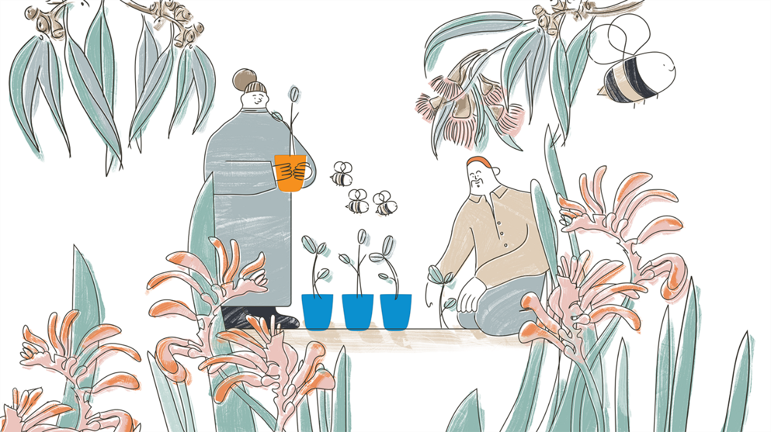
The goal of this plan is to clearly identify objectives, outcomes, actions and advocacy priorities for our houses to work towards more sustainable and resilient houses and communities.
This document also provides further context to critical issues relating to climate change and their relationship to the work of neighbourhood houses, including:
- the vital contribution of neighbourhood houses to sustainability and community resilience,
- our role as advocates,
- how our houses are impacted directly by climate change, and
- the resourcing required to support this work.

BACKGROUND

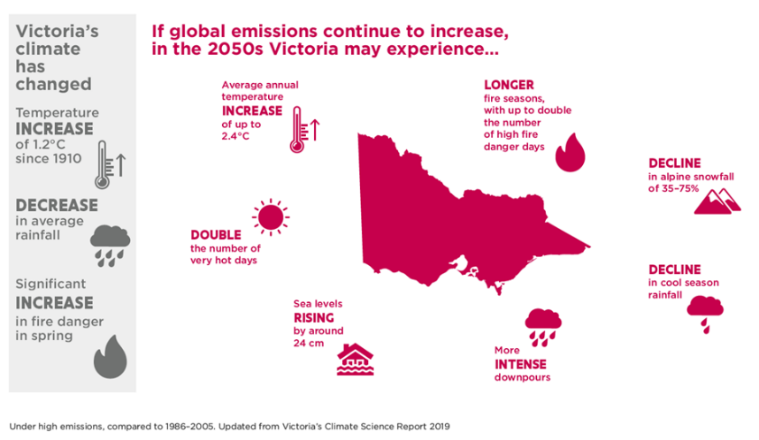
Our changing climate is not just a future threat. Australia is already seeing the devastating consequences of climate change in many communities. Increasing greenhouse gas emissions are making global temperatures rise, the oceans more acidic, and extreme weather - such as heatwaves, storms, floods and bushfires - more frequent and intense.
In Victoria, it is projected that without rapid global action on climate change, very hot days will double by 2050, with longer fire seasons and more intense downpours. A range of quantifiable projected changes to Victoria’s climate are outlined in Figure 1.

Figure 1 – The anticipated impact of climate change in Victoria by 2050 if global greenhouse gas emissions continue at their current rate (compared to 1966-2005) (Source: Victoria’s Climate Science Report 2019)

CLIMATE JUSTICE
It is clear that climate change affects us all, but it is also evident that it affects some people in our community more than others.
Whilst some of us can go out to buy another fan or a portable air conditioner if our house gets unbearably hot, others cannot – for a raft of reasons that include experiencing social and economic inequity, disability, particular health conditions, social isolation, and age. Thus, there is an ongoing parallel conversation around climate justice when talking about resilience. Vulnerability to climate change can depend on a range of factors. Neighbourhood houses are often on the front line – creating connections with, and providing services to, the people most vulnerable in the community and most at-risk to climate change impacts.
MITIGATION

Neighbourhood houses can help to play an important role in mitigating climate change by taking action to reduce greenhouse gas emissions and waste within their own organisation and also by encouraging action within their local communities. Obvious examples include tackling food miles through supporting community gardens and reducing organic waste by providing community composting hubs, and/or educating the community about effective and manageable gardening and composting at home.

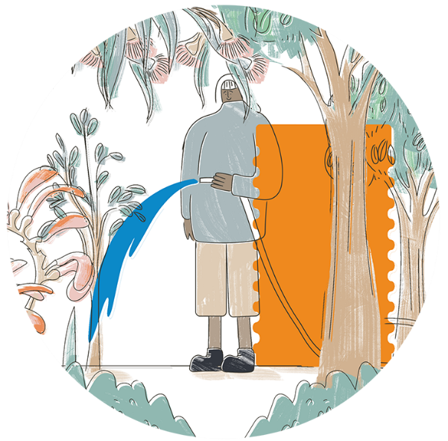
ADAPTATION
Neighbourhood houses also play a significant role in supporting communities in adapting to a changing climate - taking action to prepare for and reduce the severity of both current and future impacts. We don’t know what the future will hold so to reduce future impacts we need to think about risks, who is vulnerable and why, under a range of possible scenarios.
Adapting to a changing climate can include technical actions, such as using water resources more efficiently or upgrading community buildings to be safe and a comfortable harbour for the community through hotter summers. It can also include social actions, such as building neighbourhood connections to reduce social isolation and ensuring the most vulnerable have networks they can call on, or people to check in on them in extreme weather events.
RESILIENCE
There has been frequent reference in the context of climate change to the need to build resilience.
We can think of resilience in terms of individual resilience – the ability of an individual to cope with trauma or challenges they face in their lives, and in terms of community resilience – the ability of our society to adapt, change and transform in response to shocks and stresses.
Community resilience can be understood in several ways. It is founded on minimising risks to the community in the first place, requiring improvements across a range of aspects which affect everyday life such as access to safe and quality housing and infrastructure and access to services and supports. Many stakeholders must work together to build community resilience. It can also be understood as how a community can come together to support each other during times of crisis. We see interesting examples everywhere of communities becoming empowered through resilience building – a recent example is the formation of the Mallacoota & District Recovery Association following the 2019/20 bushfire event.
Community resilience can depend on a range of factors. Emergency Management Victoria has identified seven characteristics of community resilience highlighted in Figure 2 below.
Culturally rich & vibrant | Diversity is celebrated, and the community has a range of cultural, arts and leisure activities accessible by all.
Connected, inclusive and empowered | There are networks and structures in a community that support collaboration, communication, sharing, reaching out to others and learning together.
Safe and well | A community is physically and mentally healthy, and it is a safe place to be. Community wellbeing is high.
Sustainable built and natural environment | High levels of amenities are accessible to all. Ecosystem services are valued and sustainable.
Dynamic and diverse local economy | There are diversified and accessible employment opportunities and a sustainable work-life balance.
Reflective and aware | A community can access the resources it needs to be aware, to act where required and reflect upon their experiences in order to inform future preparedness and response.
Democratic and engaged | A community is able to participate in decision-making and community activities.
Figure 2 – Seven characteristics of a resilient community identified by Emergency Management Victoria

SUSTAINABLE DEVELOPMENT
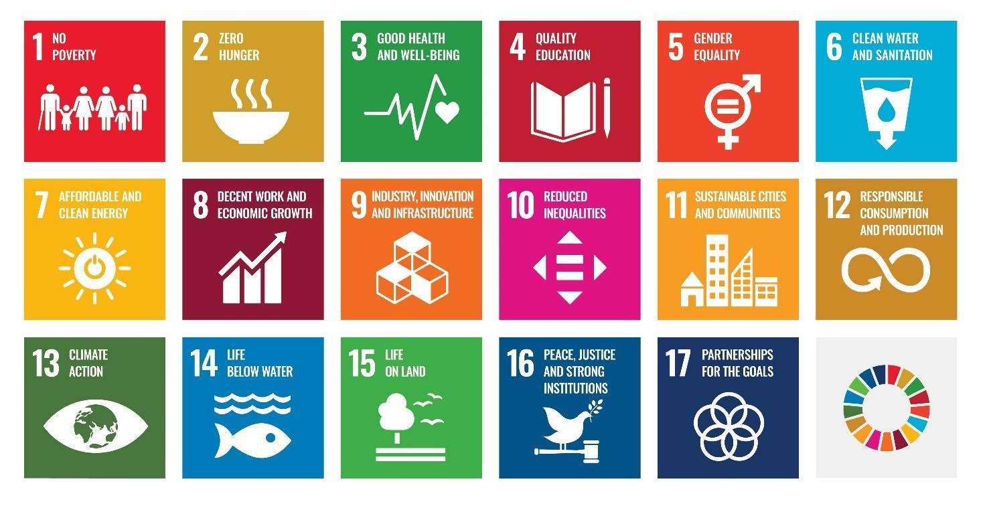
Sustainable development seeks to achieve equity across generations. A sustainable development perspective incorporates environmental, social, political and economic concerns into all aspects of decision-making.
The United Nations Sustainable Development Goals (SDGs) were adopted in 2015 by all United Nations member states as part of the 2030 Agenda for Sustainable Development.

These 17 goals are an urgent call to action to bring peace and prosperity for people and the planet, now and into the future. The SDGs recognise that ending poverty and other deprivations must be coupled with health, education, equity and economic inclusion, whilst also promoting ecological and climate justice.
Figure 3 – The United Nations Sustainable Development Goals

The core work of neighbourhood houses inherently links to many SDGs such as SDG 10 (reduce inequalities) and SDG 3 (good health & wellbeing). Some SDGs are also directly relevant to community action on climate change, such as SDG 13 (take urgent action to combat climate change and its impacts) and SDG 12 (responsible consumption).

Importantly, these goals and associated actions are often interconnected and interdependent. Finding synergies between these goals offers more significant opportunities to achieve them. In shaping this action plan, we have looked for these synergies, highlighting how our actions on climate and community resilience also address many of the SDGs.
NEIGHBOURHOOD HOUSES

Neighbourhood houses are creative and inclusive physical spaces that encourage community connections, support the most vulnerable in the neighbourhood and provide opportunities for everyone to live active, sustainable and fulfilling lives. They are run as community-based organisations that support the priorities of their local neighbourhood. There are over 400 neighbourhood houses across Victoria and over a thousand across Australia.
Neighbourhood houses are supported nationally by the Australian Neighbourhood Houses and Centres Association (ANHCA). The state peak body is Neighbourhood Houses Victoria (NHV). The vast majority of houses are underpinned by ongoing base funding from the State Government – but are also expected to cobble together their own unique mix of local government and program funding, supplemented by short-term grant funding to deliver their equally unique mix of services. As part of the State Government funding arrangements, neighbourhood houses are supported by a regional coordinator. Many also choose to form local government (LGA) based networks, particularly if they receive local government funding.
The majority of neighbourhood houses already have sustainability embedded in their policy documents, and many have a track record of engaging in a range of activities and actions that promote climate action and sustainable living. Examples include education and courses on food systems that empower participants and inspire sustainable change, hosting community climate action groups, providing information on renewable energy, reducing their own energy use and waste through energy efficiency upgrades and recycling programs, along with supporting local government engagement on the lived experience of climate change for at-risk community groups.
NEIGHBOURHOOD HOUSES AND COMMUNITY RESILIENCE
We see time and time again that in a community emergency, neighbourhood houses are often the first to step up and respond. For example, Olinda Community House expanded into a fully functioning relief centre following the recent storm in the Dandenong Ranges, providing information and support for the community across mental health and wellbeing, referrals for temporary accommodation, social connection, insurance support and financial aid, among other services. And Bairnsdale Neighbourhood House was all over the news coordinating emergency support during the relatively recent bushfires in East Gippsland.

Their structure as small, community-driven, flexible and adaptable grassroots organisations gives them the ability to shift gears and priorities quickly and efficiently. Their community connection and trusted community presence often make them a natural community hub in times of emergency, including extreme events.
Neighbourhood houses go beyond the emergency response and play an essential part in rebuilding communities after tragic events. Kinglake Ranges Neighbourhood House, for example, has taken an ongoing role in supporting their community for the long haul post-Black Saturday.
Importantly, neighbourhood houses also take a preventative approach, building the resilience of communities by addressing the underlying drivers of vulnerability. This is essentially their core business.
Examples include:
- Running playgroups that connect young families to reduce social isolation and loneliness.
- Provision of food relief for people experiencing food insecurity.
- Providing adult education programs and training to increase employability.
- Providing computer classes for older people to build digital literacy.
- Supporting people with disabilities to join activities and access the same opportunities as their abled counterparts.
- Referring public housing tenants to support services.
Neighbourhood houses are a valuable resource that can respond to the community’s needs and priorities and engage those most marginalised and socially isolated. With climate change bringing new threats to our communities, this unique capacity to respond is becoming increasingly important.

NEIGHBOURHOOD HOUSES AS ADVOCATES
Neighbourhood houses play an important role in community advocacy. Through their relationships with local communities, they have in-depth knowledge of the key issues affecting individuals and their broader community, wide-reaching community networks, political connections, trust and goodwill. Every day neighbourhood houses connect individuals to specific services or care such as NDIS provision or food relief, advocating to local council and Members of Parliament and other relevant bodies on issues of importance to their local community. This role not only builds individual resilience and capacity to respond to climate change but by advocating for, and supporting communities to advocate for themselves, neighbourhood houses are building trust and the ability to inform local and state governments to more effectively address community needs.
NEIGHBOURHOOD HOUSES ARE ALSO IMPACTED BY CLIMATE CHANGE
Neighbourhood houses are often at the frontline in responding to community needs during periods of extreme weather. Houses themselves, however, are also at risk of disruption during these periods of heightened need. For example, communication systems may be down, or air-conditioners may not be working due to a power outage, or staff and volunteers may not be able to get to work due to inaccessible roads or public transport.
Neighbourhood houses themselves need the support and resources to adapt and build organisational resilience so that they can minimise impacts on the health and wellbeing of their participants, volunteers and staff and, in turn, support wider community resilience. Planning for an uncertain future is a challenging task and neighbourhood houses need to be supported to understand the vulnerability of their houses and the community under a range of possible future scenarios.

NEIGHBOURHOOD HOUSE RESOURCING
The capacity of houses to adapt is highly dependent on resourcing. Neighbourhood Houses Victoria identified limiting factors that undermine or cap the ability of the sector to do more, including:
- The part-time nature of the core neighbourhood house funding
- The lack of sustainable ongoing activity or program funding to support inclusion
- The predominantly one-off nature of existing funding opportunities
- The cost, availability and time required for training is challenging. In particular in rural areas.

“Time and time again throughout this project [of exploring climate vulnerabilities], the importance of this sector has been emphasised, and the key barrier that is holding them back from realising their potential in this space is a lack of resources, funding, time and capacity.”
Northern Alliance for Greenhouse Action (NAGA)

THE DAREBIN NEIGHBOURHOOD HOUSE NETWORK

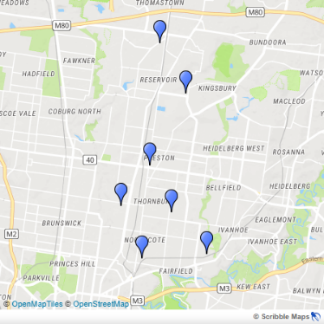
There are six neighbourhood houses in the
Darebin Neighbourhood House Network. They are:
- Alphington Community Centre
- Bridge Darebin (Preston and Thornbury)
- Jika Jika Community Centre
- PRACE
- Reservoir Neighbourhood House
- Span Community House
These houses have all been a part of their local neighbourhood since the 1980s and play a critical and trusted role in the social infrastructure of the Darebin LGA.
As a collective, the Darebin Neighbourhood House Network is able to strengthen the influence of each of our individual houses and our capacity for action and advocacy, amplifying our individual voices. Working together also enables us to share skills, capabilities and resources.
Neighbourhood houses respond and evolve according to community needs which means each house has different strengths, interests and abilities. In the Darebin network some houses have 50 staff, some have only 3. Some primarily support older residents and young families, others primarily work with residents in nearby public housing estates. Some houses are better positioned to lead on particular actions and have a greater capacity to play different roles during a time of crisis.

As an example of the extensive range of services provided by the Darebin neighbourhood houses and our collective impact, on one day during the Covid-19 pandemic, the network provided close to 600 community meals and hundreds of food relief packages, physical activities for over 60 people, social connection for 377 people, facilitated the contribution of 50 volunteer hours, and made over 750 sales of social enterprise goods. In monetary terms, on any typical day, it is estimated that our houses in Darebin provided approximately $42,000 in value to the community.

The Darebin Network collegiately taps into its distributed capacity – efficiently and effectively sharing resources. By building collective knowledge around community needs and issues, and sharing skills and expertise gained through responding to the changing priorities of the community we support, we are constantly innovating and growing. The development of this shared Climate Change Adaptation and Resilience Plan is part of this process.

STATE AND LOCAL GOVERNMENT POLICY CONTEXT

The Victorian Government and Darebin City Council have listened to the community and are committed to acting on climate change and building community resilience. In shaping the Darebin Network’s Climate Action and Resilience Plan, we considered how our actions could strategically contribute to objectives identified by state and local government. Appendix A highlights some key plans and policies of state and local government that helped shape our plan, including the:
- Health and Human Services Climate Change Adaptation Action Plan 2022–2026
- Greater Melbourne Regional Adaptation Strategy
- Darebin Climate Emergency Plan 2017-22, and
- Darebin Council Plan 2021-2025.

CLIMATE ACTION AND RESILIENCE PLAN
“Well informed, grass roots, localised action on a global scale offers the best chance for mitigating the most dire climate change scenarios while adapting successfully to emerging conditions that are now essentially unavoidable.”
CEO of The Royal Society of Victoria, Mike Flattley, reflecting on the value of neighbourhood houses
The Darebin Neighbourhood House Network has identified four key objectives for our houses to work towards more sustainable and resilient houses and communities, as set out in the Table below.
In the next pages we have articulated the outcomes we aspire to as a network, and actions and advocacy priorities to guide our work in this space in the coming years. In shaping this action plan we have also looked for synergies with the Sustainable Development Goals (SDGs), highlighting how our actions on climate and community resilience also address many of the goals outlined on page 8.
As a network, we have committed to reviewing this document in two years to look at how we have done and reflect on how we can further progress action on climate and building the resilience of our houses and our community.
CLIMATE ACTION AND RESILIENCE OBJECTIVES AND OUTCOMES
Objectives | Outcomes
1. Sustainable Houses  We actively reduce our environmental footprint and look after our natural environment. | 1.1 – Reduced waste and carbon emissions at our houses through energy, water, transport, waste minimisation and the food system.  1.2 – A thriving natural environment that supports biodiversity at our houses.  1.3 – Staff, volunteers and participants are informed and empowered to act on climate change and sustainability goals.
2. Resilient Houses  We work to build our resilience to extreme weather and adapt to the changing climate. | 2.1 – Our houses provide a safe and comfortable environment for staff, volunteers and participants during extreme weather events.  2.2 – Our houses are enabled to serve the community during periods of disruption.  2.3 – Our houses are informed, connected, and empowered to adapt to a changing climate and respond to the needs of the community.
3. Sustainable Communities  We help our community to reduce their environmental footprint and look after the natural environment. | 3.1 – Reduced waste and carbon emissions in Darebin through energy, waste minimisation and the food system.  3.2 – A thriving natural environment that supports biodiversity in Darebin.  3.3 – A community informed and empowered to act on climate change and sustainability.
4. Resilient Communities  We help our community to build resilience, adapt to the changing climate and mitigate the impacts of extreme weather. | 4.1 – Our community is socially connected and healthy through more frequent and extreme weather events.  4.2 – Our community is prepared, informed and empowered, with the capacity to respond and adapt to a changing climate.  4.3 – Vulnerable communities have equitable access to opportunities and resources that enable them to live sustainable and resilient lives.
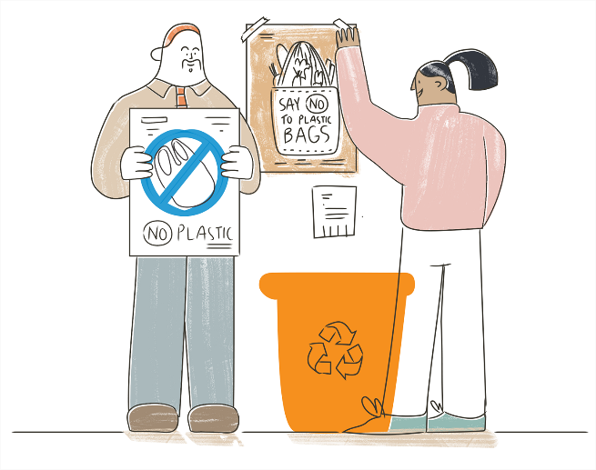

ADVOCACY PRIORITIES
Adv1 | We will advocate to improve the energy and water efficiency of all Council owned neighbourhood houses.
Adv2 | We will advocate for governments to identify minimum requirements for all neighbourhood houses to be safe,  efficient and resilient to climate related impacts.
Adv3 | We will advocate that all future infrastructure upgrades to our buildings also help us improve our energy  efficiency and build our resilience to climate change.
Adv4 | In the face of climate uncertainty, we will advocate to Darebin Council to connect asset focused and health and  wellbeing focused risk assessments and planning so that neighbourhood houses can themselves plan  holistically for future scenarios.
Adv5 | We will advocate for the physical and social infrastructure required to ensure the health and wellbeing  of our community in a changing climate. This includes,  ∙ Building a clear shared understanding of what is required to create a safe and comfortable environment  for different community cohorts through periods of extreme weather, and  ∙ Assessing the role of neighbourhood houses to provide community support under different scenarios.
Adv6 | We will amplify and promote the role of neighbourhood houses in building climate resilience and advocate for  adequate resourcing to do this important work.
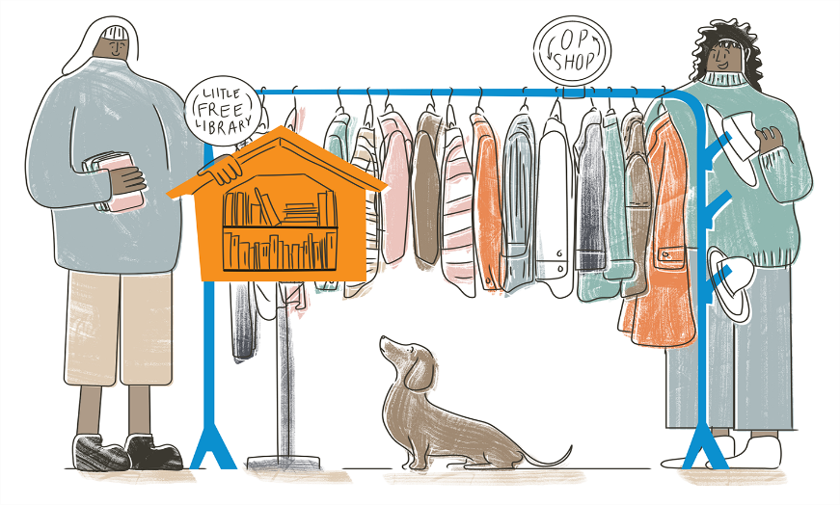

PRIORITY ACTIONS
PRIORITY ACTIONS TO SUPPORT ALL OBJECTIVES
 | Action | Resourcing
AO1 | Offer professional development for all team members across the network on sustainability, climate change adaptation and resilience. | Requires additional funding
AO2 | Strengthen partnerships and collaboration to enable collective action across Darebin to address climate change. | Existing budget
AO3 | Investigate how neighbourhood houses can be better enabled to support the climate action and community resilience objectives of federal, state and local governments, and articulate this role and contribution in public forums. | Existing budget
AO4 | Amplify First Nations leadership and knowledge to guide climate action planning. | Requires additional funding

OBJECTIVE 1 – SUSTAINABLE HOUSES

We actively reduce our environmental footprint and look after our ecosystem.
- Reduced waste and carbon emissions at our houses through energy, water, transport, waste minimisation and the food system.
- A thriving natural environment that supports biodiversity at our houses.
- Staff, volunteers and participants are informed and empowered to act on climate change and sustainability goals.

 | Action | Resourcing | Aligned SDGs
A1.1 | Strengthen a unified network voice to have input to Council’s climate change planning. | Existing budget | 11. 13. 16.
A1.2 | Continue to embed sustainability principles into strategic plans, policies, programs and services. | Existing budget | 12. 13.
A1.3 | Action opportunities to reduce our energy, water, food, waste and transport footprint. | Requires additional funding | 6. 11. 12. 13.
A1.4 | Action opportunities to improve how our outdoor spaces contribute to the flora and fauna biodiversity of our neighbourhood. | Requires additional funding | 3. 11. 13. 15.

OBJECTIVE 2 – RESILIENT HOUSES

We work to build our resilience to extreme weather and adapt to the changing climate.

- Our houses provide a safe and comfortable environment for staff, volunteers and participants during extreme weather events.
- Our houses are enabled to serve the community during periods of disruption.
- Our houses are informed, connected, and empowered to adapt to a changing climate and respond to the needs of the community.

 | Action | Resourcing | Aligned SDGs
A2.1 | Strengthen the capacity of the network to communicate, collaborate and effectively share resources during periods of disruption. | Requires additional funding | 11. 12. 17.
A2.2 | Incorporate climate change adaptation actions into strategic plans, risk management frameworks and policies to help minimise service disruption (e.g. heatwave preparedness and response policy for each house) taking into consideration different scenarios. | Existing budget | 11. 12. 17.

OBJECTIVE 3 – SUSTAINABLE COMMUNITIES
We help our community to reduce their environmental footprint and look after our ecosystem.
- Improved sustainability and reduced carbon emissions in Darebin in energy, waste and the food system.
- A community informed and empowered to act on climate change and sustainability.

 | Action | Resourcing | Aligned SDGs
A3.1 | Share information about climate action initiatives within and across our community to build knowledge and ensure all of the community is engaged and empowered. | Existing budget | 4. 11. 13.
A3.2 | Support other organisations and community groups to deliver sustainability programs. | Requires additional funding | 16. 17.
A3.3 | Enable households to reduce emissions within the food system, including food miles and waste. | Requires additional funding | 2. 9. 12.
A3.4 | Lead by example by introducing reduce-reuse-recycle principles across all programs and activities, including for third parties hiring our venues. | Existing budget | 9. 12.

OBJECTIVE 4 – RESILIENT COMMUNITES
We help our community build resilience to extreme weather and adapt to the changing climate.

- Our community is socially connected and healthy through more frequent and extreme weather events.
- Our community is prepared, informed and empowered, with the capacity to respond and adapt to a changing climate.
- Vulnerable communities have equitable access to the opportunities in the transition to a low-emissions economy, including green jobs and climate appropriate housing.

 | Action | Resourcing | Aligned SDGs
A4.1 | Continue to develop programs to ensure those most at-risk of social isolation and loneliness in our community are well connected so that they can be supported during periods of forced isolation (e.g., heatwaves). | Existing budget | 3. 5. 10.
A4.2 | Continue to strengthen community connections between generations, neighbours and cultures to build climate resilience. | Existing budget | 13. 17.
A4.3 | Expand access to information and resources and provide pathways to existing support programs that help our community to be more resilient to extreme weather and adapt to the changing climate. | Requires additional funding | 1. 3. 4.
A4.4 | Investigate best practice to maintain neighbourhood house databases of contacts, networks, and organisations, to enable effective and efficient communications and support for the Darebin community during periods of disruption. | Requires additional funding | 13. 16.

APPENDIX A – POLICY CONTEXT
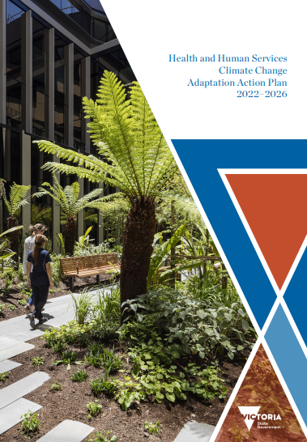
The Victorian Government and Darebin City Council have a number of strategic plans and policies to drive climate action and community resilience. This section highlights some key priorities and actions that have helped shape the Darebin Neighbourhood House Network’s Climate Action and Resilience Plan 2022, including the Health and Human Services Climate Change Adaptation Action Plan 2022–2026, the Greater Melbourne Regional Adaptation Strategy, the Darebin Climate Emergency Plan 2017-22, and the Darebin Council Plan 2021-2025.
Health and Human Services Climate Change Adaptation Action Plan 2022–2026
The Health and Human Services Climate Change Adaptation Action Plan 2022–2026 seeks to put climate change adaptation at the forefront of policy decision-making across the sector. The plan highlights strategic actions to be implemented by the Health and Human Services system to address climate change.
There are three strategic action areas in this sector plan that have informed the network’s Climate Action and Resilience Plan 2022:
- Infrastructure resilience
- Public and stakeholder engagement on climate resilience and health
- Sector capability
Neighbourhood houses are a critical part of the health and human services infrastructure of Victoria, receiving core funding from the Department of Families, Fairness and Housing, which is guided by this sector adaptation action plan. Neighbourhood houses are an important piece of the puzzle to achieve the strategic actions within this action plan. For example, supporting public engagement through the relationships they hold with diverse community groups, in particular with those who live in social housing and those who may have higher rates of engagement with health infrastructure such as people with disabilities or older people.

The sector adaptation plan’s focus on “developing options to manage the impacts of urban heat” and “securing climate-resilient health infrastructure” highlights the important role of the physical and social infrastructure of neighbourhood houses during periods of extreme weather and the need to ensure facilities are fit-for-purpose. Aligning with the sector adaptation plan to build the sector capability offers opportunities for collaboration between neighbourhood house networks and government to effectively and equitably adapt to climate change.

Greater Melbourne Regional Adaptation Strategy
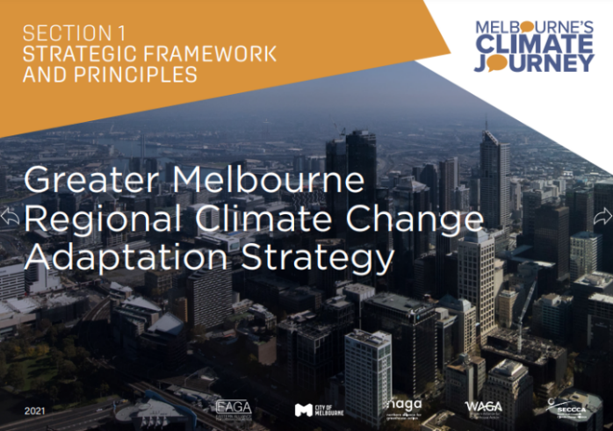
The Greater Melbourne Regional Adaptation Strategy is driven and owned by local communities and stakeholders, identifying strategic priorities and actions for adaptation and resilience building in Greater Melbourne. Examples of relevant key action areas include,
- Supporting climate resilient service delivery (Action Area 2)
- A focus on supporting the most at-risk communities and people (Action Area 5)
There are a number of priorities in the strategy that have informed the network’s Climate Action and Resilience Plan 2022.
Some examples include,
- Ensure that the people most at-risk are not worse off in a changing climate. This is an opportunity to address the disadvantage and inequality that exists today.
- Deliver communications and engagement projects for at-risk groups, including identifying a network of community leaders.

- Support community service organisations to build their resilience and business continuity to minimise disruptions to service delivery. Build and/or upgrade existing community buildings, such as Community and Neighbourhood Houses, to create a network of safe resilient places where people can go in weather extremes.
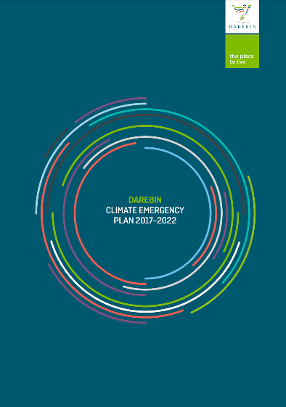
Darebin Climate Emergency Plan 2017-22
In 2016 Darebin City Council became the first government body in the world to declare a climate emergency, releasing the Darebin Climate Emergency Plan 2017-2022 the following year. This initiative, spurred on by local community members, sparked a global movement, with hundreds of councils across multiple countries now calling for a climate emergency response.

The Darebin Climate Emergency Plan 2017-22 identifies overarching goals related to climate change mitigation, adaptation and resilience-building. Among others, these goals include,

- To provide maximum protection for the community of Darebin, especially the most vulnerable.
- To restore a safe climate at emergency speed.
- To enable the community to be resilient to the impacts of climate change.
- To engage, empower and mobilise communities and organisations to take action.

Darebin Council Plan 2021-2025

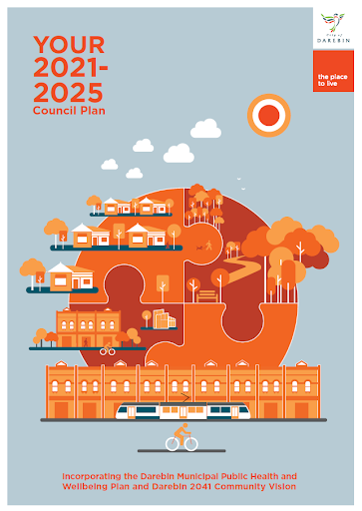
The Darebin Council Plan 2021-2025 incorporating Darebin’s Municipal Public Health and Wellbeing Plan and the Darebin 2041 Community Vision provides pathways to address health and wellbeing objectives, aligning strategic objectives with Council’s climate action and resilience priorities.
Many of the Council Plan strategic objectives are relevant to the work of Neighbourhood houses in Darebin. Some examples are highlighted below.

- Strategic Objective 1.2: We will help to build an inclusive and empowered community, where social cohesion and community harmony are fostered.
- Strategic Objective 1.4: We will increase social connection to reduce isolation and loneliness, and support positive mental health
- Strategic Objective 3.1 We will adapt to climate change and build the resilience of our community, infrastructure and the built environment, with a focus on our vulnerable communities at risk of fuel poverty, and flooding.
Others include, “reducing carbon emissions… through community focused initiatives” (3.4) and “reducing waste and stimulating a local circular economy” (3.5).

APPENDIX B – DEFINITIONS & ACRONYM

ADAPTIVE CAPACITY: The capability of a system, sector or social group to adjust to climate change, to minimise harm, to act on opportunities, or to cope with the consequences.

CLIMATE CHANGE: Long-term changes in temperatures and weather patterns which are attributed directly or indirectly to human activity that alter the composition of the global atmosphere in addition to natural climate variability observed over comparable time periods. Human activities such as burning fossil fuels (coal, oil and gas), industrial agriculture and deforestation have been the main drivers of climate change since the 1800s.

CLIMATE CHANGE MITIGATION: Intervention(s) to reduce greenhouse
gas emissions (the gasses that cause climate change) such as generating renewable energy from wind and solar instead of burning coal or gas, reducing cars on the road (e.g.increasing use of public transportation or cycling), planting trees (which absorb greenhouse gases) and reducing waste.

CLIMATE CHANGE ADAPTATION: Actions taken in response to actual or projected climate change and impacts that lead to a reduction in risks or a realisation of benefits.

CLIMATE JUSTICE: Justice that links development and human rights to achieve a human-centred approach to addressing the changing climate, safeguarding the rights of the most vulnerable people and sharing the burdens and benefits of climate change and its impacts equitably and fairly.

COMMUNITY RESILIENCE: Community resilience is the ability of our society to adapt, change and transform in response to shocks and stresses. It is a broad concept which encompasses nine core elements including strength in local knowledge, community networks and relationships, communication, health, governance and leadership systems, as well as sufficient resources, economic investment, disaster preparedness, and positive mental outlook.

IPO: The Indigenous Peoples’ Organisation – Australia is a national coalition of 300 Aboriginal and Torres Strait Islander peak organisations, community organisations, and individual members across Australia. IPO recognise the holistic nature of systems which support the healing of climate and Country and has identified overarching priorities and legislative priorities to achieve these goals.

LGA: Local Government Area

NEIGHBOURHOOD HOUSES VICTORIA: The peak body for 400 neighbourhood houses and community centres across Victoria.

RESILIENCE: According to the IPCC (2018) resilience may be defined as, “the capacity of social, economic and environmental systems to cope with a hazardous event or trend or disturbance, responding or reorganizing in ways that maintain their essential function, identity and structure while also maintaining the capacity for adaptation, learning and transformation.”
SUSTAINABILITY: A range of dynamic processes which ensure the equitable endurance of natural and human systems (e.g. reducing waste to landfill, composting food waste or switching to energy efficient appliances).
SUSTAINABLE DEVELOPMENT: Development that balances social, economic and environmental concerns and meets present needs without negatively impacting the ability of future generations to meet their own needs.

SUSTAINABLE DEVELOPMENT GOALS (SDGs): The 17 global goals for development for all countries established by the United Nations through a participatory process and elaborated in the 2030 Agenda for Sustainable Development.

UNFCCC: United Nations Framework Convention on Climate Change

VULNERABILITY: The degree to which a system, sector or social group is susceptible to the adverse effects of climate change; vulnerability depends on the nature of the climate changes to which the system is exposed, its sensitivity to those changes and its adaptive capacity.

REFERENCES

Carpenter, S, R., Arrow, K. J., Barrett S, Biggs, R., Brock, W. A., Crépin, A-S., Engström, G., Folke, C., Hughes T .P., Kautsky N., Li C-Z., McCarney G., Meng K., Mäler K-G., Polasky S., Scheffer, M., Shogren, J., Sterner, T., Vincent, J,R., Walker, B., Xepapadeas, A., & Zeeuw, A., D. (2012). General Resilience to Cope with Extreme Events. Sustainability. 4(12), 3248-3259

Darebin City Council Neighbourhood Houses. (2021). $167,699 community
value provided in just 4 days in COVID-19 restricted settings! Neighbourhood Houses Victoria.

Darebin City Council. (2017). Darebin Climate Emergency Plan 2017-2022. https://www.darebin.vic.gov.au/-/media/Council/Files/Waste-and-environment/Sustainable-Darebin/Energy-and-climate/DarebinClimateEmergencyPlan_updated5Dec2018_webready.ashx

Darebin City Council. (2021). The Darebin Council Plan and Health & Wellbeing Plan 2021-2022. https://www.darebin.vic.gov.au/-/media/council/files/about-council/council-structure-and-performance/council-plan/councilplanactionplan2021-2022.ashx

Department of Families, Fairness and Housing. (2022). Health and Human Services Climate Change Adaptation Action Plan 2022–2026. https://www.health.vic.gov.au/sites/default/files/2022-02/health-human-services-climate-change-adaptation-action-plan-2022-2026_0.pdf

Emergency Management Victoria. (2017). Community Resilience Framework for Emergency Management. https://files.emv.vic.gov.au/2021-08/Community%20Reslience%20Framework%20for%20Emergency%20Management.pdf

Ferntree Gully News. (2021, June 19). Storm Damage Support. Ferntree Gully News. https://ferntreegullynews.com/2021/06/19/storm-damage-support-resources/

Folke, C., Carpenter, S., Elmqvist, T., Gunderson, L. & Walker, B. (2021). Resilience: Now more than ever. Ambio, 50(10), 1774–1777. https://link.springer.com/content/pdf/10.1007/s13280-020-01487-6.pdf

IPCC, 2022: Summary for Policymakers [H.-O. Pörtner, D.C. Roberts, E.S. Poloczanska, K. Mintenbeck, M. Tignor, A. Alegría, M. Craig, S. Langsdorf, S. Löschke, V. Möller, A. Okem (eds.)]. In: Climate Change 2022: Impacts, Adaptation, and Vulnerability. Contribution of Working Group II to the Sixth Assessment Report of the Intergovernmental Panel on Climate Change [H.-O. Pörtner, D.C. Roberts, M. Tignor, E.S. Poloczanska, K. Mintenbeck, A. Alegría, M. Craig, S. Langsdorf, S. Löschke, V. Möller, A. Okem, B. Rama (eds.)]. Cambridge University Press. In Press. https://www.ipcc.ch/report/ar6/wg2/downloads/report/IPCC_AR6_WGII_SummaryForPolicymakers.pdf

IPCC, 2018: Annex I: Glossary [Matthews, J.B.R. (ed.)]. In: Global Warming of 1.5°C. An IPCC Special Report on the impacts of global warming of 1.5°C above pre-industrial levels and related global greenhouse gas emission pathways, in the context of strengthening the global response to the threat of climate change, sustainable development, and efforts to eradicate poverty [Masson-Delmotte, V., P. Zhai, H.-O. Pörtner, D. Roberts, J. Skea, P.R. Shukla, A. Pirani, W. Moufouma-Okia, C. Péan, R. Pidcock, S. Connors, J.B.R. Matthews, Y. Chen, X. Zhou, M.I. Gomis, E. Lonnoy, T. Maycock, M. Tignor, and T. Waterfield (eds.)]. In Press. https://www.ipcc.ch/site/assets/uploads/sites/2/2019/06/SR15_Full_Report_High_Res.pdf

Indigenous Peoples’ Organisation-Australia (IPO). (2021). Heal Country, Heal Climate Priorities for Climate and Environment. https://www.ohchr.org/sites/default/files/2022-03/indigenous-peoples-organization2.pdf

Lowtija Institute. (2021). Climate Change and Aboriginal and Torres Strait Islander Health discussion paper. https://www.lowitja.org.au/content/Image/Lowitja_ClimateChangeHealth_1021_D10.pdf

Mallacoota and District Recovery Association (MADRA). (2022). MADRA Community-led Recovery. https://madrecovery.com/wp-content/uploads/2021/09/MADRA-Disaster-Recovery-Plan-Sep-2021.docx

McShane, I.,Coffey, B. (2022). Rethinking community hubs: community facilities as critical infrastructure In: Current Opinion in Environmental Sustainability, 54, 1 - 6. https://www.sciencedirect.com/science/article/pii/S187734352200001X

NAGA. (2018).Exploring vulnerabilities: Recommendations Report. https://www.naga.org.au/uploads/9/0/5/3/9053945/exploring_vulnerabilities_-_recommendations_report_-_april_2021.pdf

Neighbourhood Houses Victoria. (2019). Submission to the Royal Commission into Victoria’s Mental Health System. http://rcvmhs.archive.royalcommission.vic.gov.au/Neighbourhood_Houses_
Victoria.pdf

Neighbourhood Houses Victoria. (2021). Making Climate a Priority. https://www.nhvic.org.au/news/making-climate-a-priority

Neighbourhood Houses Victoria. (2022). Advocacy Priorities. https://www.nhvic.org.au/advocacy-priorities

Patel, S. S., Rogers, M. B., Amlôt R., Rubin, G, J. (2017). What Do We Mean by 'Community Resilience? A Systematic Literature Review of How It Is Defined in the Literature. PLoS currents, 9. https://pubmed.ncbi.nlm.nih.gov/29188132/

Pope, J & Warr, D. (2005). Strengthening local communities
An overview of research examining the benefits of Neighbourhood Houses. https://vgls.sdp.sirsidynix.net.au/client/search/asset/1292626

Sachs, J. D. (2015). Goal-based development and the SDGs: implications for development finance. Oxford Review Of Economic Policy, 31(3–4), 268-278. https://academic.oup.com/oxrep/article-abstract/31/3-4/268/1800433?redirectedFrom=fulltext

Sachs, J. D. (2015). The Age of Sustainable Development.
Columbia University Press.

Schieh, L. (2020). Neighbourhood Houses and Disaster Recovery. https://www.nhvic.org.au/faqs/neighbourhood-houses-and-disaster-recovery

The State of Victoria Department of Environment, Land, Water and Planning. (2021). Greater Melbourne Regional Climate Change Adaptation Strategy. https://engage.vic.gov.au/download/document/20910

The State of Victoria Department of Environment, Land, Water and Planning (DELWP). (2021). Victoria’s Climate Change Strategy. https://www.climatechange.vic.gov.au/__data/assets/pdf_file/0026/521297/Victorian-Climate-Change-Strategy.pdf

United Nations. (2015). Transforming Our World:
The 2030 Agenda for Sustainable Development. https://sdgs.un.org/2030agenda#:~:text=We%20resolve%2C%20between%20now%20and,protection%20of%20the%20planet%20and

Wandin, D. (2019). Weaving Indigenous Knowledge Into Agriculture. https://rsv.org.au/indigenous-agriculture/

Zhenmin, L. Espinosa, P. (2019). Tackling climate change to
accelerate sustainable development. Nature Climate Change, 9, 494–496. https://www.nature.com/articles/s41558-019-0519-

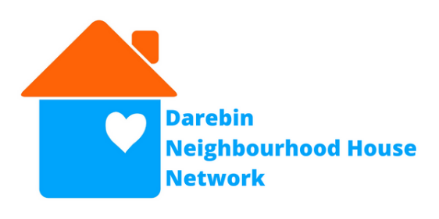
Darebin Neighbourhood House Network

Alphington Community Centre
alphington.org.au
info@alphington.org.au

Bridge Darebin
bridgedarebin.org.au
connect@bridgedarebin.org.au

Jika Jika Community Centre
Jikajika.org.au
admin@jikajika.org.au

Reservoir Neighbourhood House
reservoirnh.org.au
admin@reservoirnh.org.au

Span Community House
spanhouse.org
info@spanhouse.org

Prace
prace.vic.edu.au
office@prace.vic.edu.au

This Climate Action and Resilience Framework for Neighbourhood Houses was developed by Darebin Neighbourhood House Network and Jesuit Social Services’ Centre for Just Places in 2022 with funding support from Darebin City Council and Melbourne’s Climate Journey.
Melbourne’s Climate Journey is a community-led project supporting Greater
Melbourne communities to adapt to a changing climate, supported by the
Department of Environment, Land, Water and Planning (DELWP) and funded through the Supporting Our Regions to Adapt program.

For more information and guidance on how your neighbourhood house can build more sustainable and resilience houses and communities contact just.places@jss.org.au.

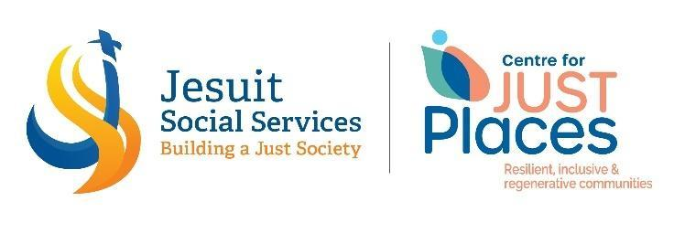

Indigenous Peoples’ Organisation-Australia (IPO). (2021). Heal Country, Heal Climate Priorities for Climate and Environment. (Weblink)
Lowtija Institute. (2021). Climate Change and Aboriginal and Torres Strait Islander Health discussion paper. (Weblink)
Wandin, D. (2019). Weaving Indigenous Knowledge into Agriculture. (Weblink)
Neighbourhood Houses Victoria. (2021). Making Climate a Priority. (Weblink)
Darebin City Council Neighbourhood Houses. (2021). $167,699 community value provided in just 4 days in COVID-19 restricted settings! Neighbourhood Houses Victoria.
IPCC, 2022: Summary for Policymakers [H.-O. Pörtner, D.C. Roberts, E.S. Poloczanska, K. Mintenbeck, M. Tignor, A. Alegría, M. Craig, S. Langsdorf, S. Löschke, V. Möller, A. Okem (eds.)]. In: Climate Change 2022: Impacts, Adaptation, and Vulnerability. Contribution of Working Group II to the Sixth Assessment Report of the Intergovernmental Panel on Climate Change [H.-O. Pörtner, D.C. Roberts, M. Tignor, E.S. Poloczanska, K. Mintenbeck, A. Alegría, M. Craig, S. Langsdorf, S. Löschke, V. Möller, A. Okem, B. Rama (eds.)]. Cambridge University Press. In Press.
The State of Victoria Department of Environment, Land, Water and Planning (DELWP). (2021). Victoria’s Climate Change Strategy. (Weblink)
IIPCC (2022) Climate Change 2022: Impacts, Adaptation, and Vulnerability, Summary for Policy Makers.
Folke, C., Carpenter, S., Elmqvist, T., Gunderson, L., & Walker, B. (2021). Resilience: Now more than ever. Ambio, 50(10), 1774–1777.
MADRA. (2022). MADRA Community-led Recovery. (Weblink)
Emergency Management Victoria. (2017). Community Resilience Framework for Emergency Management. (Weblink)
Sachs, J. (2015). The Age of Sustainable Development. Columbia University Press.
United Nations. (2015). Transforming Our World: The 2030 Agenda for Sustainable Development. (Weblink)
Ibid.
Sachs, J. D. (2015). Goal-based development and the SDGs: implications for development finance. Oxford Review Of Economic Policy, 31(3–4), 268-278.
Zhenmin, L., & Espinosa, P. (2019). Tackling climate change to accelerate sustainable development. Nature Climate Change, 9, 494–49.
Schieh, L. (2020). Neighbourhood Houses and Disaster Recovery. (Weblink)
Ferntree Gully News. (2021, June 19). Storm Damage Support. Ferntree Gully News. (Weblink)
McShane, I., & Coffey, B. (2022). Rethinking community hubs: community facilities as critical infrastructure. Current Opinion in Environmental Sustainability, 54, 1-6. (Weblink)
Pope, J. & Warr, D. (2005). Strengthening local communities, an overview of research examining the benefits of Neighbourhood Houses.
Neighbourhood Houses Victoria. (2022). Advocacy Priorities. (Weblink)
Neighbourhood Houses Victoria. (2019). Submission to the Royal Commission into Victoria’s Mental Health System. (Weblink)
NAGA. (2018). Exploring vulnerabilities: Recommendations Report, 9. (Weblink)
Darebin City Council Neighbourhood Houses. (2021). $167,699 community value provided in just 4 days in COVID-19 restricted settings! Neighbourhood Houses Victoria.
Victorian Government (2022). Health and Human Services Climate Change Adaptation Action Plan 2022-2026. (Weblink)
Department of Environment, Land, Water and Planning. (2021). Greater Melbourne Regional Climate Change Adaptation Strategy (Weblink)
Darebin City Council. (2017). Darebin Climate Emergency Plan 2017-2022. (Weblink)
Darebin City Council. (2021). The Darebin Council Plan and Health & Wellbeing Plan 2021-2022 (Weblink)
Department of Environment, Land, Water and Planning. (2021). Greater Melbourne Regional Climate Change Adaptation Strategy, (Weblink) DELWP. (2021). Greater Melbourne Regional Climate Change Adaptation Strategy. (Weblink)
Darebin City Council. (2017). Darebin Climate Emergency Plan 2017-2022. (Weblink)
Darebin City Council. (2021). The Darebin Council Plan and Health & Wellbeing Plan 2021-2022. (Weblink)
Department of Families, Fairness and Housing. (2022). Health and Human Services Climate Change Adaptation Action Plan 2022–2026. (Weblink)
Darebin City Council. (2017). Darebin Climate Emergency Plan 2017-2022 (Weblink)
Darebin City Council. (2021). The Darebin Council Plan and Health & Wellbeing Plan 2021-2022 (Weblink)
Ibid.
IPCC, 2018: Annex I: Glossary [Matthews, J.B.R. (ed.)]. In: Global Warming of 1.5°C. An IPCC Special Report on the impacts of global warming of 1.5°C above pre-industrial levels and related global greenhouse gas emission pathways, in the context of strengthening the global response to the threat of climate change, sustainable development, and efforts to eradicate poverty [Masson-Delmotte, V., P. Zhai, H.-O. Pörtner, D. Roberts, J. Skea, P.R. Shukla, A. Pirani, W. Moufouma-Okia, C. Péan, R. Pidcock, S. Connors, J.B.R. Matthews, Y. Chen, X. Zhou, M.I. Gomis, E. Lonnoy, T. Maycock, M. Tignor, and T. Waterfield (eds.)]. In Press
Carpenter, S, R., Arrow, K. J., Barrett S, Biggs, R., Brock, W. A., Crépin, A-S., Engström, G., Folke, C., Hughes T .P., Kautsky N., Li C-Z., McCarney G., Meng K., Mäler K-G., Polasky S., Scheffer, M., Shogren, J., Sterner, T., Vincent, J,R., Walker, B., Xepapadeas, A., & Zeeuw, A., D. (2012). General Resilience to Cope with Extreme Events. Sustainability. 4(12), 3248-3259 (Weblink)
Indigenous Peoples’ Organisation-Australia (IPO). (2021). Heal Country, Heal Climate Priorities for Climate and Environment. (Weblink)
IPCC, 2018: Annex I: Glossary [Matthews, J.B.R. (ed.)]. In: Global Warming of 1.5°C. An IPCC Special Report on the impacts of global warming of 1.5°C above pre-industrial levels and related global greenhouse gas emission pathways, in the context of strengthening the global response to the threat of climate change, sustainable development, and efforts to eradicate poverty [Masson-Delmotte, V., P. Zhai, H.-O. Pörtner, D. Roberts, J. Skea, P.R. Shukla, A. Pirani, W. Moufouma-Okia, C. Péan, R. Pidcock, S. Connors, J.B.R. Matthews, Y. Chen, X. Zhou, M.I. Gomis, E. Lonnoy, T. Maycock, M. Tignor, and T. Waterfield (eds.)]. In Press
United Nations. (2015). Transforming Our World: The 2030 Agenda for Sustainable Development. (Weblink)
Ibid

